融合报道、应用创新参评作品推荐表

|  |  |  |  |  |  |  |  |  |  |  |  |  |
| --- | --- | --- | --- | --- | --- | --- | --- | --- | --- | --- | --- | --- |
| 作品标题 | 创意视频｜千年丝路 | | | | | | 参评项目 | 融合报道 | | | | |
| 字数/时长 | 05分39秒 | | | | |
| 主创人员 | 张国锋、曹朝阳、张梦琳、乔可、杨福庆、许佳颖、高志明 | | | | | | 编辑 | 集体（王茫茫、丁小月、尚江龙、李璟奕、吴宇涵、韩朗、须艳雯、杨以轩、曹勇、吴凯强、贺晓东、高远、林芳珂、陈明、李玉凯、孙志富、阮晓旋、刘元昊、李栋、李光亚、李承阳、王兴华、刘亚林、刘永、徐薇、高怡铭、须砚文、吕昕玥、丁丽波、宋家苗、夏欣月） | | | | |
| 原创单位 | 长城新媒体集团 | | | | | | 发布平台 | 冀云客户端 | | | | |
| 发布日期 | 2023年12月16日10时03分37秒 | | | | | | | | | | | |
| 作品链接  和二维码 | 千年丝路二维码  https://jiyun.hebyun.com.cn/pages/2023/12/15/bb4ba1c63ee841d180cff42fad2c1f8d.html | | | | | | | | | | | |
| 作品简介  （采编过程） | **2023年是习近平总书记提出共建“一带一路”倡议十周年，12月16日“一带一路”国际日之际，长城新媒体集团携手中国国际电视台（CGTN）、中央电视台新闻包装工作室，共同推出《创意视频丨千年丝路》。作品在虚拟演播室中实现人景互动，通过搭建全3D场景，实现穿越古今，横跨中外的效果：从中国桑蚕技术传出说起，沿汉、唐、宋、元直至当代，娴熟的技术手段、逼真的环境场景、清晰质感的镜头设计，生动形象反映出丝绸之路的千年发展变化及沿线人民的交流互惠。** | | | | | | | | | | | |
| 社会效果 | **融合报道手段跨越了时空隔阂和文化差异，在北美最具影响力的华语电视台汉天卫视以及IPTV-Kylin、麒麟电视、Charming-China魅力中国及local BTV APP等海外电视台播出，信号覆盖3500万受众群；部分内容随CGTN在海外落地，影响辐射非洲、欧洲、北美洲及拉美地区，形成国际化矩阵式传播。** | | | | | | | | | | | |
| 初评评语  （推荐理由） | **以共建“一带一路”倡议提出十周年为时代背景，融合多种新媒体技术手段，纵穿古今，横跨中外，展现自古以来丝绸之路沿线，中外交往的千年变化。同时，作品通过创新性和艺术化的呈现，为网友展开了一幅新媒体的古丝绸之路画卷，用讲故事的办法做好重大主题的有效表达，以新媒体融合手段带来极致体验，实现主流新媒体产品的破圈转播。**  签名：  （加盖单位公章）  2024年 月 日 | | | | | | | | | | | |
| 联系人 | 张梦琳 | | | 邮箱 | 44495806@qq.com | | | | | 手机 | | 18610086277 |
| 地址 |  | | | | | | | | | 邮编 | |  |
| 以下仅自荐、他荐参评作品填写 | | | | | | | | | | | | |
| 自荐作品所获  奖项名称 | | 河北新闻奖二等奖 | | | | | | | | | | |
| 推荐人姓名 | | 贾海丽 | 单位及职称 | | | 长城新媒体集团 高级编辑 | | | 电话 | | 13831117528 | |
| 推荐人姓名 | | 何晓 | 单位及职称 | | | 长城新媒体集团 高级编辑 | | | 电话 | | 18503268321 | |
| 联系人姓名 | | 张梦琳 | 手机 | | | 18610086277 | | | 电话 | |  | |
| 推荐理由及  推荐人意见 | | **作品将“一带一路”倡议提出十周年的重大主题，运用先进的融媒体技术和3D建模手法，构建出多个生动奇妙的沉浸式场景，赋予厚重的历史文化选题新的生命力和传播力。作品构思独特新颖，镜头设计巧妙，场景构建如梦如幻，人景互动自然流畅，全片充满趣味性，给观看者身临其境的震撼体验。**  推荐人（两名）签名：自荐、他荐人签名：  （单位自荐、他荐的，由单位  负责人签名并加盖单位公章）  2024年 月 日 2024年 月 日 | | | | | | | | | | |
| 审核单位意见 | | 自荐、他荐人所在的省级记协、中央新闻单位、中国行业报协会等负责对作品政治方向、舆论导向、业务水平及报送材料审核把关并盖章确认。    （加盖单位公章）  2024年 月 日 | | | | | | | | | | |

二维码：



截图：

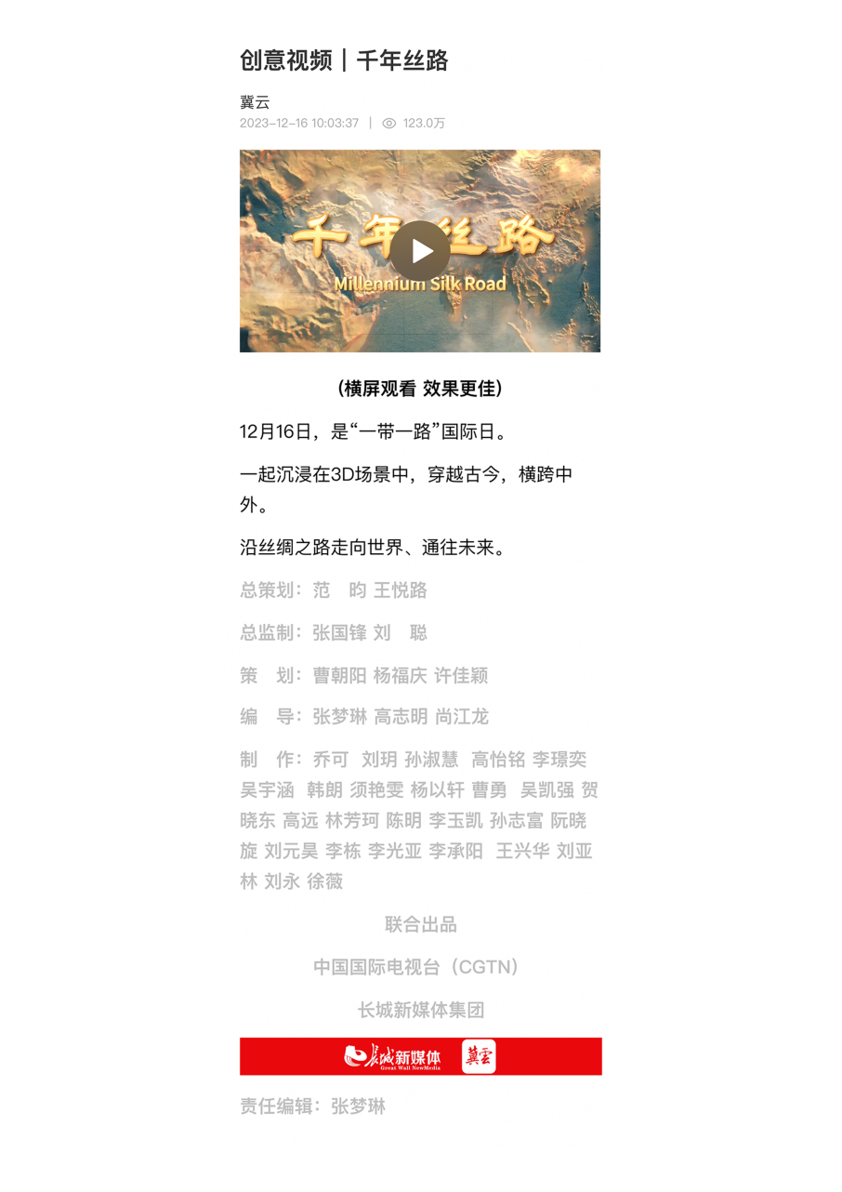

**创意视频丨千年丝路文字稿**

**同期：**

At this workshop in ancient China, workers carefully raise these caterpillars to obtain raw silk. And then come the unravelling, spinning, and embroidery processes.

在这个中国古代作坊里，工人们精心饲养蚕以获得生丝，再进行缫丝、纺丝和刺绣等工序。

From here, the smooth fabric and sericulture techniques went far to the West.

由此，柔然光滑的织品和养蚕技术传到了遥远的西方。

An abundance of technologies travelled along the Silk Road. Among them, as you could imagine by the name of it, silk farming.

丝绸之路成为大量技术传播的通道。养蚕技术就是其中之一。

**字幕：**

曼陀铃,起源于西亚。

Mandolin was originated in the West and Central Asia.

随着丝绸之路传入中国,

It made its way to China through the Silk Road

而后逐渐演变成了我们熟悉的琵琶。

and evolved into Pipa.

**同期：**

Wow.Welcome to Dunhuang.

哇，欢迎来到敦煌。

**字幕：**

敦煌

Dunhuang

**同期：**

A place that witnessed the convergence of diverse cultures.

这里是中西方文化交流的重镇。

Look,Zhang Qian is also featured here. A pioneer of the Silk Road,

看,我们也可以在敦煌壁画里看到张骞先驱,他是丝路的开创先驱。

**字幕：**

张骞的两次出使，

his two voyages to the Western Regions

为各民族的交流、交往、交融打下了基础。

have laid the foundation for the communication and blending of various nationalities.

**同期：**

Meet the man who pioneered the Silk Road over 2000 years ago.

让我们来认识一下两千多年前丝绸之路的开辟者。

Zhang Qian,an envoy of China's Han Dynasty,embarked on two missions from the ancient capital Chang'an.

张骞，汉朝使节，曾两度从古都长安出发出使西域。

**字幕：**

张骞

Zhang Qian

**同期：**

His epic arduous journey brought back first-hand accounts of the people and lands beyond the western border.

历经史诗般艰苦跋涉的旅程，他带回了有关西域各国风土人情的一手见闻。

**字幕：**

唐 长安

Chang'an Tang Dynasty

**同期：**

Behind me right here is the Big Wild Goose Pagoda.

在我身后的建筑是大雁塔。

It was built to persevere the Buddha scroll which was brought back to Chang'an, or today's Xi'an, by Master Xuanzang.

用来保留玄奘法师从西域带回长安（今西安）的佛经。

**字幕：**

在唐代，丝路贸易发达，中西方文化交流频繁。

In the Tang Dynasty, along with trade came profound cultural exchanges between China and the West.

在公元7至10世纪，制糖术和医药学在唐代从印度传入中国。

Technologies on sugar-making and medicine arrived in China from India during the Tang Dynasty between the 7th and 10th Centuries.

**同期：**

Chang'an, today's Xi'an, was one of the world's busiest trading hubs.Here's a glimpse of the city's largest commercial district,the West Market.

长安（今天的西安），曾是世界上最繁忙的贸易枢纽之一。这儿是长安最大的的商业区之一，长安西市大街的一角。

Foreign merchants acquired Chinese-made silk, tea, porcelain, lacquerware, and ironware here and shipped them to other Asian countries, Africa and Europe, while spices, gems, horses, and exotic foods like grape, watermelon, and walnut flowed to China from overseas.

来自世界各地的商人从这里将中国生产的丝绸、茶叶、瓷器、漆器、铁器销往亚洲、非洲和欧洲国家,并从海外市场运回香料、宝石、马匹, 以及葡萄、西瓜、核桃等外来食物品种。

Silk was the name card of Chinese exports.So prominent that in 1877, German geographer Baron von Richthofen first named these trade routes as the "Silk Road".

丝绸是中国出口商品的独特名片。1877年，德国地理学家李希霍芬首次将东西方贸易通道称为“丝绸之路”。

The light of cultural exchanges continued to shine through in the following Song and Yuan Dynasties.

丝绸之路上的文化交流在宋代和元代继续发扬光大。

**字幕：**

宋

Song

元

Yuan

**同期：**

In 10th Century, when China was in its Song Dynasty, two things significantly increased rice yields.One, a more advanced irrigation system. And two, the introduction of a drought-resistant and early maturing strain of rice in Champa,located in what is now Central Vietnam.

在公元10世纪中国的宋代，两项技术大大增加了水稻的产量。

一项是关于先进的灌溉系统，另一项则关于在占城（位于现在的越南中部）引进了一种抗旱和早熟的水稻品种。

**字幕：**

明

Ming

从明代开始，随着世界联系的更加紧密，

As the maritime “Silk Road” rose in prominence during the Ming Dynasty,

海上“丝绸之路”逐渐在历史舞台中成为主角。

the world became more closely interlinked.

这个转变是以郑和下西洋为标志的。

This shift was marked by Zheng He's voyages to the West.

**配音：**

Zheng He brought advanced production technologies on his missions, which enabled Chinese migrants to survive and thrive on foreign land. They were also crucial to economic development in Southeast Asia.

郑和下西洋带去了先进的生产技术，增强了华人移民的发展能力

对东南亚的当地垦荒和经济发展发挥了重要作用。

**同期：**

A thousand years later, China is able to use its home-grown hybrid rice technology to feed over 20-percent of the world's population with just 10-percent of the world's total arable land.

1000年后，中国能够利用其自主研发的杂交水稻技术，以全球10%的可耕地面积，养活大于全球人口总量20%的人群。

**字幕：**

20%全球人口总量

World's population

10%可耕地面积

Arable land

**同期：**

Hybrid rice has been adopted by Pakistan, Bangladesh and other countries along the New Silk Road, helping with food security in less-developed, populous nations.

杂交水稻技术也被广泛应用于巴基斯坦、孟加拉和新丝绸之路沿线的其他国家，帮助欠发达的人口大国实现粮食安全。

**配音：**

The thousand-year-old ancient Silk Road can find its modern day glory, as it was renewed a decade ago.In 2013, China proposed the Belt and Road Initiative.

百年丝路，悠悠千载，中外文化交流传承千年。顺应时代潮流，中国于2013年提出了“一带一路”合作倡议。

**同期：**

Countries on board have done a remarkable job in the excavation, research and protection of cultural relics.

中国与沿线国家在文物发掘、研究以及保护工作上合作成果不断。

**字幕：**

中哈边境 霍尔果斯陆路口岸

Khorgos Dry Port China-Kazakhstan border

**同期：**

Welcome to the Khorgos Dry Port on the China-Kazakhstan border, once a bustling stop on the ancient Silk Road, now the world's largest dry port and first cross-border free commercial zone.By July 2022, China-Europe freight trains had completed 57,000 journeys since the railway opened in 2011,transporting millions of containers of merchandise worth nearly 300 billion US dollars.

欢迎来到位于中哈边境的霍尔果斯陆路口岸,这里曾经是古丝绸之路上的繁忙驿站，现在是世界上最大的陆地港和首个跨境自由商业区。自2011年开通到2022年7月，中欧班列累计开行5万7千列运送了数以百万计的集装箱，货物价值近3千亿美元。

**字幕：**

China Railway Express (Mar.2011-Jul.2022)

57,000 journeys

$300 bln of goods

截至2023年11月，中欧班列已累计开行8.1万列,通达欧洲25个国家的217个城市。

By November 2023, over 81,000 China-Europe freight trains have been operated, reaching destinations including 25 European countries and 217 cities.

**同期：**

Goods from eastern China can now reach western Europe in just two weeks by train.

如今，中国东部的货物经火车运送到达西欧仅需两周的时间。

**字幕：**

目前，已有至少150多个国家和30多个国际组织加入共建“一带一路”倡议。

More than 150 countries and 30 international organizations have now signed up to the Belt and Road Initiative.

在过去十年，中国与“一带一路”沿线经济体贸易额年均增长8.6%。

Over the past decade, trade between China and Belt and Road economies has grown by an average of 8.6% annually.

2023年10月，第三届“一带一路”国际合作高峰论坛成功举办，各方共形成458项成果。

In October 2023, the Third Belt and Road Forum for International Cooperation was successfully held with a total of 458 results achieved by all parties.

**同期：**

Spanning the Eurasian continent for millennia, the Silk Road has always been a symbol of exchange and sharing.

It connected peoples and culture,and helped transcend differences that kept the world apart.

曾经，丝绸之路绵延万里。而今，一带一路倡议亦被认作文明交流和共享的纽带。这条纽带凝聚了人心，沟通了文化，跨越了差异，连通了世界。